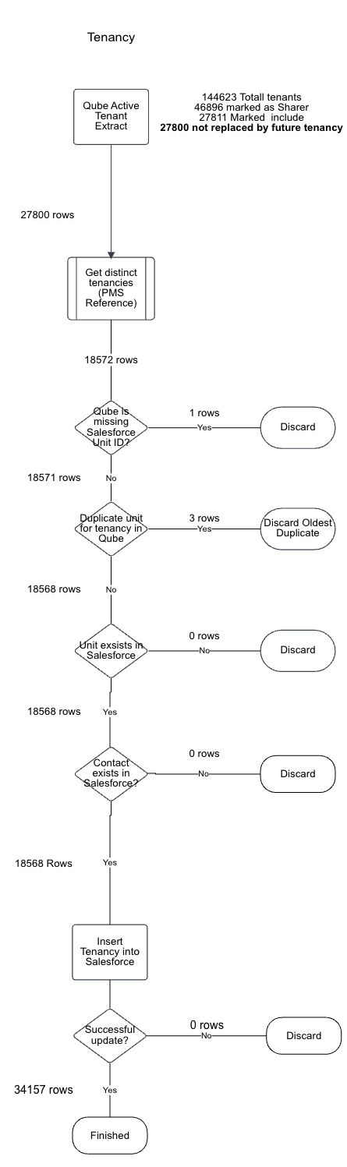
Cube Missing Unit ID
Duplicate Unit for Tenancy in Qube

